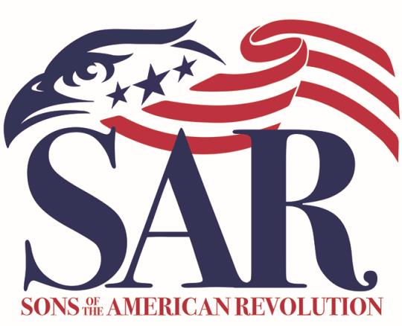

WITHLACOOCHEE CHAPTER
Sons of the American Revolution April.10.2021

The General Meeting of the Withlacoochee Chapter of the SAR was called to order at _10:33_ by Chapter President Dave Hitchcock.
NOTE; This General Meeting is being displayed on Zoom for those members who are unable to attend.

Invocation - ______David Hitchcock _________
Pledge of Allegiance - _
The SAR Pledge: - Larry Sturgeon ___ __
The American Creed - Charles Day
Members in Attendance- See attached list
- Attendance 26 Members
Introduction of Guest - _Robert Folk Jr
- Susan Camillo, Anne Camillo, Faeth Houle, Kim Bennett, Carolyn Ohimeyer, Kathe Echlin, Carol Weiser, Priscilla Tyson, Sarah Shepard, Troy Shepard, Benjamin Shepard, Anna Shepard, Fawn McGee
Opening Comments – ____Members in need of prayer__
- Danial Hans passed on 4-9-2021.
- Say a prayer for all members and family who are sick or are in need of payer.
BRITHDAYS FOR THE MONTH
- Chauncey Reich, Bob Highbaugh, Ronald Powell, Jimmie Barnes, John Elley
INDUCTION OF NEW MEMBERS
- No new members inducted this month.
Awards Presentation:
- Mrs. Susan Camillo was presented a U.S. Flag with box and an SAR Memorial Medallion. Susan’s Grandson John Matthew Camillo is a member of the SAR (Resigned, 2011) and is a member of the Withlacoochee Chapter.
- Speaker Fawn McGee was presented a Certificate of Appreciation.
SPEAKER__ Fawn McGee_____
- Speaking about Women in the Military and the different rules, benefits, and policies imposed on them. She also presented brief synopses of her Army career.
Committee Reports:
Treasurer’s Report – Richard Bailey, Treasurer;
- All the accounts have been balanced and reconciled; the income for the current period were $698.00 and the expenses for the current period were $923.00. Any member inquiring of the Chapter Finances, please contact the treasurer after the meeting or by Phone or Email and the treasurer will provide the information requested.
- Motion to accept by Richard Sumner, motion 2nd by Bill Teater, and voted to accept.
Secretary’s Report – Tom Hellem, Secretary.
- The last General meeting was held on March 10, 2021and the EBM on March 27, 2021 meetings minutes are posted on the Withlacoochee Chapter web page.
- 6 members attended the 03-27-2021 EBM.
- Main discussion at the EBM was the Treasury Report, Treasurer will provide all income for the current period and all expenses for the current period; any other.
- Motion was made by Larry Sturgeon, 2nd by Bill Teater, and, voted to accept.
WYKE - _____Stephen Brown_______
- No report
Registrar Report – Stephen and Vicki Brown
  - Total members to date are 81
  - New applications under review at National are 5.
  - New applicants of 5
Veterans Committee – Larry Sturgeon/ Bill Teater
  - The VA has reviewed some of the problems of determining death benefits for decease veterans and have developed a 2-page form that can be completed and returned to the VA. VA information is to be posted on the website.
  - Bill provided information to member Veterans of numerous discounts from merchants and businesses that can be collected, and to be posted on the web site.

Poster Contest – Larry Sturgeon

Only one school is entered into this year’s contest.
JROTC/Sea Cadets/Color Guard – Russell Gibson;

Charles Day represented the Chapter Color Guard at the Last Naval Battle of the Revolution and was presented a Streamer for the Color Guard Flag on March 7, 2021. Charles Day also represented the Chapter Color Guard at the Battle of Thomas Creek event and was presented a Streamer for the Color Guard Flag on March 14, 2021.

Publicity –Mark Labadia

No report

Essay Contest – Charlie Day

Charles Day Introduced the winner of the Essay Contest, Anne Shepard and the 2nd place winner Benjamin Shepard and their family. Ms. Anna Shepard read her Essay about the events at Lexington and Concord during the Revolutionary War to audience.

Eagle Scouts – Charlie Day

No Report

Web Page Richard Bailey

Still working on moving pictures to the new site.

Now Richard is coordinating with the state secretary to make it compatible with the state website.

Newsletter– Mark Labadia,

There will be a newsletter at the end of the month and include items from the meeting, the flag award, and notes about the speaker and his presentation.
Old Business – David Hitchcock.
No old business to report

New Business – Dave Hitchcock

Chairman Folk of the ad-hock committee to review the By Laws and create the language for the change for dues payment for 50 SAR members.is still in review.

The President solicited the member to attend the state BOM.

Ending Comments – Dave Hitchcock

None

Happy Dollars- Richard Bailey

Happy Dollars are collected to supplement the cost of the programs which the chapter is involved.

SAR Recessional _Larry Sturgeon__
The meeting was adjourned at _____1:22 PM_______

UPCOMING EVENTS

Next EBM Saturday, April 24, 2021 @ 11:00 AM
Located on Horse Lake Rd. in Hernando Co. @ Beef O Brady

Next General Meeting Saturday May 8, 2021 @ 10:30 AM
Located on 509 E Hartford St. @ Citrus Hills Country Club

MEMBERSHIP ATTENDANCE
GENERAL MEETING
APRIL 10, 2021
Bailey | Richard |  | Markham
Barnes | Jimmie |  | Edward
Brock | Douglas |  | Lee
Brown | Stephen |  | Carl
Carey | John |  | Edison Edward
Cook | Robert |  | William
Day Jr. | Charles |  | Louis
Echlin | James |  | Elliott
Elley | John |  | Richard
Folk Sr. | Robert |  | James
Gibson | Russell |  | Warren
Hellem | John |  | Thomas
Highbaugh | Robert |  | Leon
Hitchcock | David |  | Francis
Hodges | Millard |  | Adair
Holme Jr. | Thomas |  | Timings
Houle | Michael |  | Paul
Powell | Ronald |  | Lee
Scheiterle II | William |  | Michael
Sturgeon | Larry |  | Dean
Sumner II | Richard |  | Lawrence
Sweeney | Paul |  | Vincent
Teater, Sr. | William |  | Gilbert
Townsend Jr. | Jack |  | L
Venard | Thomas |  | Smith
Wilder | John |  | Wesley

