**SAR Americanism Elementary School Poster Contest 2019 - 2020**

**Theme:**

***The Battle of Thomas Creek***

**Guidelines:** See Poster Contest Guidelines (Attached)

**Eligibility:** The National Society of the Sons of the American Revolution (SAR) invites all 3rd, 4th, and 5th grade students interested in the American Revolution to participate in the Americanism Elementary School Poster Contest. The contest is open to public school, parochial, home schooled, Scouting, or Children of the American Revolution member students in that same grade range. Young artists with an enthusiasm toward art, a love of American history, or a passion in creative expression can submit their posters to their local SAR chapter for competition.

**Judging levels:** School, SAR Chapter, Florida SAR State Society, SAR National Society

**Judging Time Constraints:** School Level – **American History Lesson in Class**

Chapter Level – April 30, 2020

State Level – May 1 – 3, 2020

National Level – July 2020

**Entries/School:** – Each school, or individual, submits one entry to be judged at the Chapter level.

**Supplies:** 22”x28” Poster Board will be supplied by, (Withlacoochee Chapter SAR)

Larry D. Sturgeon, 1-352-688-2947, [larrydsturgeon@hotmail.com](mailto:larrydsturgeon@hotmail.com)

**Awards:** Chapter SAR level – 1st Prize award determined by each Chapter

Good Citizenship Certificate

Chapter winner goes to State for judging

Florida State SAR level (May 2020) Cash awards TBD plus certificate

State Winner goes to National Congress judging

National SAR level – 1st Place Cash award, Blue Rosette, Certificate,

and displayed at SAR National Headquarters

for one year.

2nd Place Cash award, Red Rosette, Certificate

3rd Place Cash award, White Rosette, Certificate

(July 2020)

**Page 2**

**SAR Americanism Elementary School Poster Contest 2019 – 2020**

**Judging Information**

* Judging of the SAR Poster Contest at the school level will be conducted by school personnel. Your choice as to the selection of judges.
* Select one (1) winning poster based on the SAR Rules and Guidelines.
* **It is extremely important to remember that posters exhibiting in three dimension will be disqualified. Students should use original drawings, i.e., no computer generated artwork; or direct copy of computer content.**
* Fill out the lower half of the Florida Society Poster Contest Entry Form (Student, teacher, school information), and attach to the student poster with a paper clip.
* Call me, **Larry D. Sturgeon**, at **1-352-688-2947 or larrydsturgeon@hotmail.com**, when the winning poster has been selected and is ready for pick-up – **No later than April 24, 2020**. An SAR member will come to the school or other location and pick up the poster.
* Members of each Local Chapter of the SAR will judge all posters submitted and select three posters (1st, 2nd and 3rd place winners).
* The poster selected as the 1st place award winner at the Chapter level will be transported to the Florida SAR Board of Management meeting for judging at the State level in May 2020.
* You will be kept informed regarding the Chapter level award ceremonies to be held on, **April 11**, **2020**, as well as the State and National winners.

**Page 3**

**SAR Americanism Elementary School Poster Contest 2019 – 2020**

**Some things to keep in mind**

* Posters must be on 22” x 28” poster board (Supplied by the Withlacoochee Chapter, Sons of the American Revolution). Contact Larry D. Sturgeon, 1-352-688-2947 or larrydsturgeon@hotmail.com.
* **Three dimensional posters will be disqualified, as well as the issue below.**
* **Encourage students to be original - no computer generated clip art or direct copy of computer content.**
* Students may use any media they choose i.e., pencil, color pencil, watercolor paint, acrylic paint, crayons, color markers, and ink, etc.
* Posters will be judged using the following criteria:
  + Does the poster express the annual theme?

**“The Battle of Thomas Creek”**

* + Is it neat and visually appealing?
  + Shows originality by the student?
  + Shows artistic merit and creativity?
  + Shows evidence of research?
  + Does the poster accurately reflect the historical subject or person?
* Only one entry will be allowed per school or individual – this entry will be judged relative to all other posters submitted at the Chapter level.
* Attach the completed SAR State entry form to the back of your winning poster with 2 pieces of tape.

In **Citrus** **County**, contact (**Larry D. Sturgeon)**, larrydsturgeon@hotmail.com or 1-352-688-2947.

Larry Dean Sturgeon

**Immediate Past President**

**FLSSAR Withlacoochee Chapter**

**Chairman - FLSSAR Americanism Youth Contests Committee**

**Sons of the American Revolution**

**Page 4**

**FLORIDA SOCIETY**

**SONS OF THE AMERICAN REVOLUTION**

**AMERICANISM ELEMENTARY SCHOOL POSTER CONTEST**

**FLORIDA SOCIETY POSTER CONTEST ENTRY FORM**

**Sponsoring Chapter ____________________________________**

**Chapter President __________ ___________**

**Chapter Poster Contest Chairman _________**

**Chairman’s Address_____________________________________**

**City _____________________ State _FL___ Zip ______________**

**Number of Posters Judged by Chapter_____ E-Mail _____________________________**

**Name of Student ______________________________________ Age____ Grade____**

**Address ____________________________________________________**

**City _______________________________State _FL___ Zip________________**

**Teacher Contact & School Information**

**Teacher’s Name ____ ________________Number of Students_______**

**School’s Name _________________________________________**

**City __________________ State _FL___ Zip__________________**

**Number of Posters Competing at School ______________**

**E-Mail __________________________________________**

ATTCH 1 Form PC 2 July 22, 2009

**Page 5**

# This Day in History - May 17, 1777

### The Battle of Thomas Creek ends the Second Florida Expedition

On this day in history, May 17, 1777, the **Battle of Thomas Creek** ends the **Second Florida Expedition**, an attempt by Georgia patriots to invade British East Florida during the American Revolution. After the **French and Indian War**, eastern Florida was ceded to Great Britain by Spain. It became a separate colonial province with its capital at Saint Augustine.

East Florida had a very small population, but Saint Augustine became an important British military base. When the Revolution began, it remained loyal to the Crown and thousands of Loyalists fled there to escape persecution. The influx of people brought about a food shortage and raiding parties into Georgia were established to confiscate food and wreak havoc on Georgia patriots. In addition, the Creek Nation to the southeast was allied with the British and aided the raiding parties into Georgia.

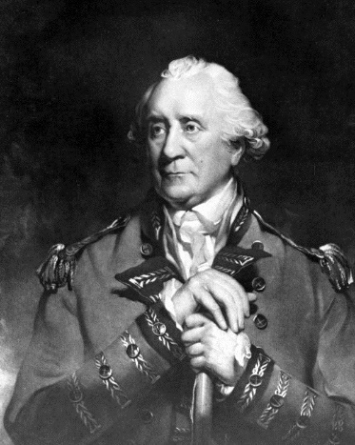

|  |
| --- |
| **Governor Patrick Tonyn**  Tonyn was the governor of East Florida at the time of the Battle of Thomas Creek. |

In response to all this, three attempts were made by Georgia to capture Saint Augustine. All three failed and were plagued by infighting. The first expedition in late 1776 failed due to food shortages and the recall of Continental Army General **Charles Lee** back to the main army. The third expedition, in the spring and summer of 1778, failed due to infighting of the leaders of different militia factions and a superior British opposing force.

**Page 6**

The **Second Florida Expedition** ended in disaster and the death of Button Gwinnett, a Georgia signer of the [Declaration of Independence](http://www.revolutionary-war-and-beyond.com/declaration-of-independence.html). As President of Georgia in early 1777, Gwinnett planned an expedition against Saint Augustine. He had no military experience, so command of the mission was given to Brigadier General **Lachlan McIntosh**, Gwinnett's chief political rival. Both tried to lead the mission, causing unnecessary delays. Their constant fighting caused the General Assembly to call them both back to Savannah after they had already left on the mission, command of which was given to Colonel **Samuel Elbert**. McIntosh and Gwinnett would famously fight a duel over who was to blame for the mission's delays and Gwinnett would be mortally wounded.



**Page 7**

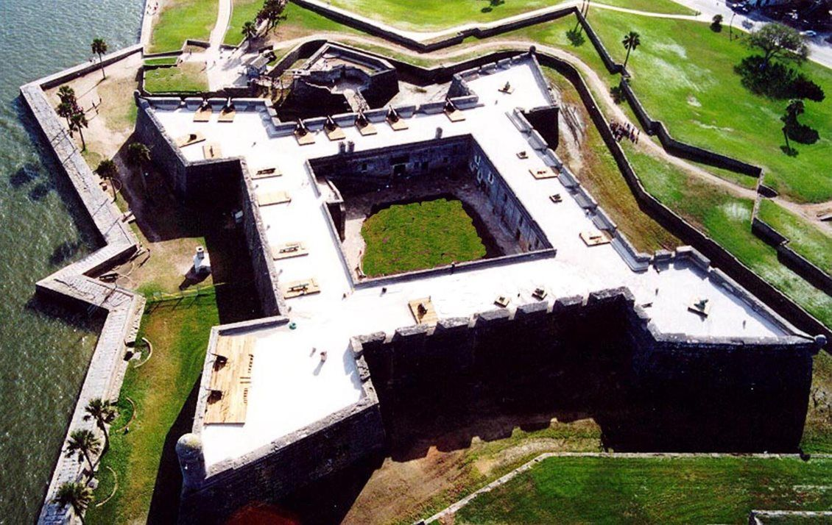*

*Castillo de San Marcos Saint Augustine, Florida Castillo de San Marcos guarded British Saint Augustine at the time of the Battle of Thomas Creek and the Georgia patriot attacks on British East Florida*

Colonel Elbert continued the expedition to East Florida, sending the cavalry over land and taking the rest himself down the coast in ships. The cavalry arrived first at the Nassau River, but were forced to wait for days for Elbert's flotilla. Meanwhile, East Florida governor, **Patrick Tonyn**, sent 200 Loyalists and Creek to ambush the approaching patriots. On May 14, Indians captured some of the patriots' horses, but one of the Indians was caught and allegedly tortured and killed by the militia, which outraged the Indians.   
  
On May 17, the cavalry reached the Loyalists who were hiding in wait at **Thomas Creek**. When they were fired upon, the surprised Georgia militia turned to flee, only to run right into more Loyalists who had come up behind them. A handful of Georgia patriots were killed or wounded, but more than 30 were captured. Unfortunately, the Creek Indians tortured half of them to death in retaliation for the alleged murder of their compatriot a few days before. The rest of the Georgia militia escaped and made their way to rendezvous with Colonel Elbert. When Elbert discovered what happened at the **Battle of Thomas Creek**, he called off the mission. They were already deep inside enemy territory, many had already been killed or captured, they suffered from food shortages and a fleet of British ships was nearby. The Americans would not attempt another invasion of East Florida.

**Page 8**

The British forces in Saint Augustine would later play an important part in the overall British strategy to reclaim the south during the latter part of the Revolution. The entire

East Florida would eventually be ceded to Spain by Britain at the end of the war and would not become part of the United States until 1822.

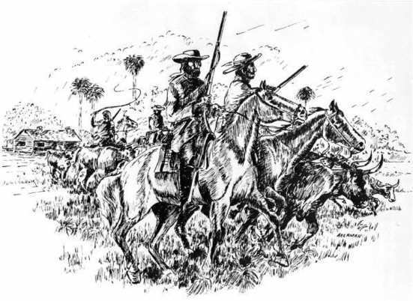

This illustration shows British rangers and Banditti harassing an American homestead. During the Revolution, these two groups raided farms and fortifications in Georgia and North Florida. The most common plunder was cattle and other livestock.

**The Battle of Thomas Creek**

**On-line References**

**The Jacksonville Historical Society:**

<http://www.jaxhistory.org/portfolio-items/battle-thomas-creek/>

* Cashin, Edward (1999). The King's Ranger: Thomas Brown and the American Revolution on the Southern Frontier. New York: Fordham University Press. [*ISBN*](https://en.wikipedia.org/wiki/International_Standard_Book_Number) [*978-0-8232-1907-0*](https://en.wikipedia.org/wiki/Special:BookSources/978-0-8232-1907-0). [*OCLC*](https://en.wikipedia.org/wiki/OCLC) [*246304277*](https://www.worldcat.org/oclc/246304277).
* Heitman, Francis (1892). [*Historical Register of Officers of the Continental Army During the War of the Revolution*](https://books.google.com/books?id=eogUAAAAYAAJ&pg=PA27#v=onepage&f=false). Nichols, Killam & Maffitt. [*OCLC*](https://en.wikipedia.org/wiki/OCLC) [*2823069*](https://www.worldcat.org/oclc/2823069).
* Jones, Charles Colcock (1883). [*The History of Georgia, Volume 1*](https://books.google.com/books?id=6HEFAAAAQAAJ&pg=PA266#v=onepage&f=false). Boston: Houghton Mifflin. [*OCLC*](https://en.wikipedia.org/wiki/OCLC) [*1816720*](https://www.worldcat.org/oclc/1816720).
* Nester, William (2004). The Frontier War for American Independence. Mechanicsburg, PA: Stackpole Books. [*ISBN*](https://en.wikipedia.org/wiki/International_Standard_Book_Number) [*978-0-8117-0077-1*](https://en.wikipedia.org/wiki/Special:BookSources/978-0-8117-0077-1). [*OCLC*](https://en.wikipedia.org/wiki/OCLC) [*260092836*](https://www.worldcat.org/oclc/260092836).
* Pennington, Edward (July 1930). "East Florida in the American Revolution, 1775–1778". The Florida Historical Society Quarterly. Florida Historical Society (Volume 9, No. 1): 24–46. [*JSTOR*](https://en.wikipedia.org/wiki/JSTOR) [*30149717*](https://www.jstor.org/stable/30149717).

**Page 9**

* Piecuch, Jim (2008). Three Peoples, One King. Columbia, SC: University of South Carolina Press. [*ISBN*](https://en.wikipedia.org/wiki/International_Standard_Book_Number) [*978-1-57003-737-5*](https://en.wikipedia.org/wiki/Special:BookSources/978-1-57003-737-5). [*OCLC*](https://en.wikipedia.org/wiki/OCLC) [*185031351*](https://www.worldcat.org/oclc/185031351).
* Searcy, Mary (1985). The Georgia–Florida Contest in the American Revolution, 1776–1778. University, AL: University of Alabama Press. [*ISBN*](https://en.wikipedia.org/wiki/International_Standard_Book_Number) [*978-0-8173-0225-2*](https://en.wikipedia.org/wiki/Special:BookSources/978-0-8173-0225-2). [*OCLC*](https://en.wikipedia.org/wiki/OCLC) [*10483821*](https://www.worldcat.org/oclc/10483821).
* Siebert, William (October 1943). "Privateering in Florida Waters and Northward in the Revolution". The Florida Historical Quarterly. Florida Historical Society (Volume 22, No. 2): 62–73. [*JSTOR*](https://en.wikipedia.org/wiki/JSTOR) [*30138486*](https://www.jstor.org/stable/30138486).

**On-line References**

**The Battle of Thomas Creek**

* [*"Florida Historical Markers Program – Nassau County"*](http://www.flheritage.com/preservation/markers/markers.cfm?ID=nassau). Florida Department of State. [*Archived*](https://web.archive.org/web/20101101040053/http:/flheritage.com/preservation/markers/markers.cfm?ID=nassau) from the original on 1 November 2010*. Retrieved 2010-10-12*.
* [*"Thomas Creek Preserve"*](https://web.archive.org/web/20120420025614/http:/apps2.coj.net/parksinternet/parkdetails.asp?parkid=339). City of Jacksonville, FL. Archived from [*the original*](http://apps2.coj.net/parksinternet/parkdetails.asp?parkid=339) on 2012-04-20*. Retrieved 2010-10-12*.

**Fort Tonyn:**

<https://en.wikipedia.org/wiki/Fort_Tonyn>

Additional References:

<https://ipfs.io/ipfs/QmXoypizjW3WknFiJnKLwHCnL72vedxjQkDDP1mXWo6uco/wiki/Battle_of_Thomas_Creek.html>

Chapter Four: Frontier War 1777 – 1778

<https://books.google.com/books/about/The_King_s_Ranger.html?id=vWmBxHo12JkC&printsec=frontcover&source=kp_read_button#v=onepage&q&f=false>

August 30, 2019